PROJECT DOCUMENTATION

Fashion Lookbook & Style Guide

Curating outfits. Simplifying fashion discovery, one lookbook at a time.

Student Name(s) | Podduturi Kartheek Reddy — 2520090015  Muppana Chinmaya Apoorva — 2520030078
Section / Branch | CSE-A / B.Tech CSE
Academic Year | III Year, II Semester, 2025–26
Course | Front End Engineering Frameworks
Course Code | 25CS1201E
Faculty Guide | Shiva Krishna, Assistant Professor
Date of Submission | [ DD Month YYYY ]

Abstract
A Fashion Lookbook & Style Guide web application is an online platform designed to help users explore fashion trends, outfit ideas, and personal styling suggestions. The application enables users to view clothing combinations, create lookbooks, and organize styles based on occasions, seasons, or individual preferences. It also serves fashion designers, boutiques, and brands by providing a digital platform to showcase their latest collections.

The application was developed as a React.js-based Single Page Application (SPA) utilizing React Router v6 for client-side navigation, component-based architecture for reusable UI, and integration with a Node.js/Express.js back end connected to MongoDB/MySQL. Key features include user authentication, fashion lookbook browsing with filtering, cart and wishlist management, and a checkout interface with payment UI. The project was built collaboratively with clearly divided module responsibilities.

Keywords: React.js, SPA, Node.js, Express.js, MongoDB, Fashion Lookbook, Cart & Wishlist, Checkout, User Authentication, REST APIs

Chapter 1: Introduction

1.1 Problem Statement
Fashion discovery is fragmented across multiple platforms, making it difficult for users to organize outfit ideas, track seasonal trends, or create personalized lookbooks in one place. There is no unified solution that combines fashion browsing, outfit curation, wishlist management, and purchasing in a single, accessible web application. This project addresses the need for a modern, interactive fashion platform that makes style discovery simple, organized, and accessible for everyday users, fashion enthusiasts, and brands alike. A React.js SPA is the ideal solution due to its component reusability, fast client-side rendering, and seamless navigation experience.

1.2 Objectives
The objectives of this project are:
- To design and implement a responsive Single Page Application (SPA) using React.js for fashion lookbook discovery.
- To implement user authentication including login, signup, and session management.
- To build a fashion lookbook module with outfit collections, filtering by occasion/season, and organized browsing.
- To develop a Cart & Wishlist system allowing users to save favourite outfits and manage purchases.
- To create a fully functional Checkout Page with order summary, address forms, and payment UI integration.
- To implement an Admin Panel for managing products, categories, and fashion collections.
- To design and maintain a scalable database structure using MongoDB/MySQL connected via REST APIs.
- To apply performance optimizations including client-side routing, lazy loading, and efficient state management.

1.3 Scope
This project implements both the front-end and back-end layers of the Fashion Lookbook & Style Guide application. The front end is a React.js SPA with full routing, dynamic content, and interactive UI components. The back end is built with Node.js and Express.js, exposing REST APIs connected to MongoDB or MySQL for persistent data storage. The project covers user authentication, product/outfit browsing, cart/wishlist functionality, checkout flow, and an admin panel. Features such as real-time inventory tracking, advanced recommendation engines, and third-party payment gateway full integration are outside the current scope.

Chapter 2: Requirements

2.1 Functional & Non-Functional Requirements
The table below lists the key requirements of the Fashion Lookbook & Style Guide system:

ID | Type | Requirement | Priority | Category
R-01 | Functional | Users can register, log in, and maintain authenticated sessions. | High | Authentication
R-02 | Functional | Users can browse outfit collections and filter by occasion, season, or style. | High | Lookbook
R-03 | Functional | Authenticated users can add/remove fashion items to/from cart. | High | Cart
R-04 | Functional | Users can save favourite outfits to a personal wishlist. | High | Wishlist
R-05 | Functional | Users can complete checkout with order summary, address, and payment UI. | High | Checkout
R-06 | Functional | Admin can add, edit, and delete products and manage fashion categories. | High | Admin Panel
R-07 | Functional | Protected routes restrict dashboard and checkout to authenticated users. | High | Routing
R-08 | Functional | Dynamic content displayed based on product/outfit ID via URL parameters. | Medium | Routing
R-09 | Non-Functional | Initial page load must complete within 3 seconds on a standard 4G connection. | High | Performance
R-10 | Non-Functional | UI must be responsive across desktop (1280px+), tablet (768px), and mobile (375px). | High | Usability

2.2 Use Case Summary
Use Case 1 — User Authentication:
- Actor: Registered/New User
- Precondition: User has internet access and visits the application.
- Main Flow: User navigates to the login/signup page, enters credentials, and is authenticated. Session is maintained for protected route access.
- Outcome: User gains access to personalized features (cart, wishlist, checkout).

Use Case 2 — Browsing & Creating a Lookbook:
- Actor: Authenticated User / Guest
- Precondition: Application loaded; fashion collections available.
- Main Flow: User browses outfit collections, applies filters (occasion, season), selects items, and adds favourites to wishlist.
- Outcome: User has an organized personal lookbook of preferred outfits.

Use Case 3 — Checkout:
- Actor: Authenticated User
- Precondition: At least one item in cart.
- Main Flow: User reviews cart, proceeds to checkout, fills address form, reviews order summary, and completes payment UI.
- Outcome: Order is placed and user receives confirmation.

Chapter 3: System Design

3.1 System Architecture
The application follows a full-stack architecture with a React.js SPA front end and a Node.js/Express.js REST API back end. The front end handles all rendering via React components and communicates with the back end via HTTP requests using Axios or the Fetch API. The back end exposes RESTful endpoints and connects to a MongoDB or MySQL database for persistent storage of users, products, orders, and cart data.

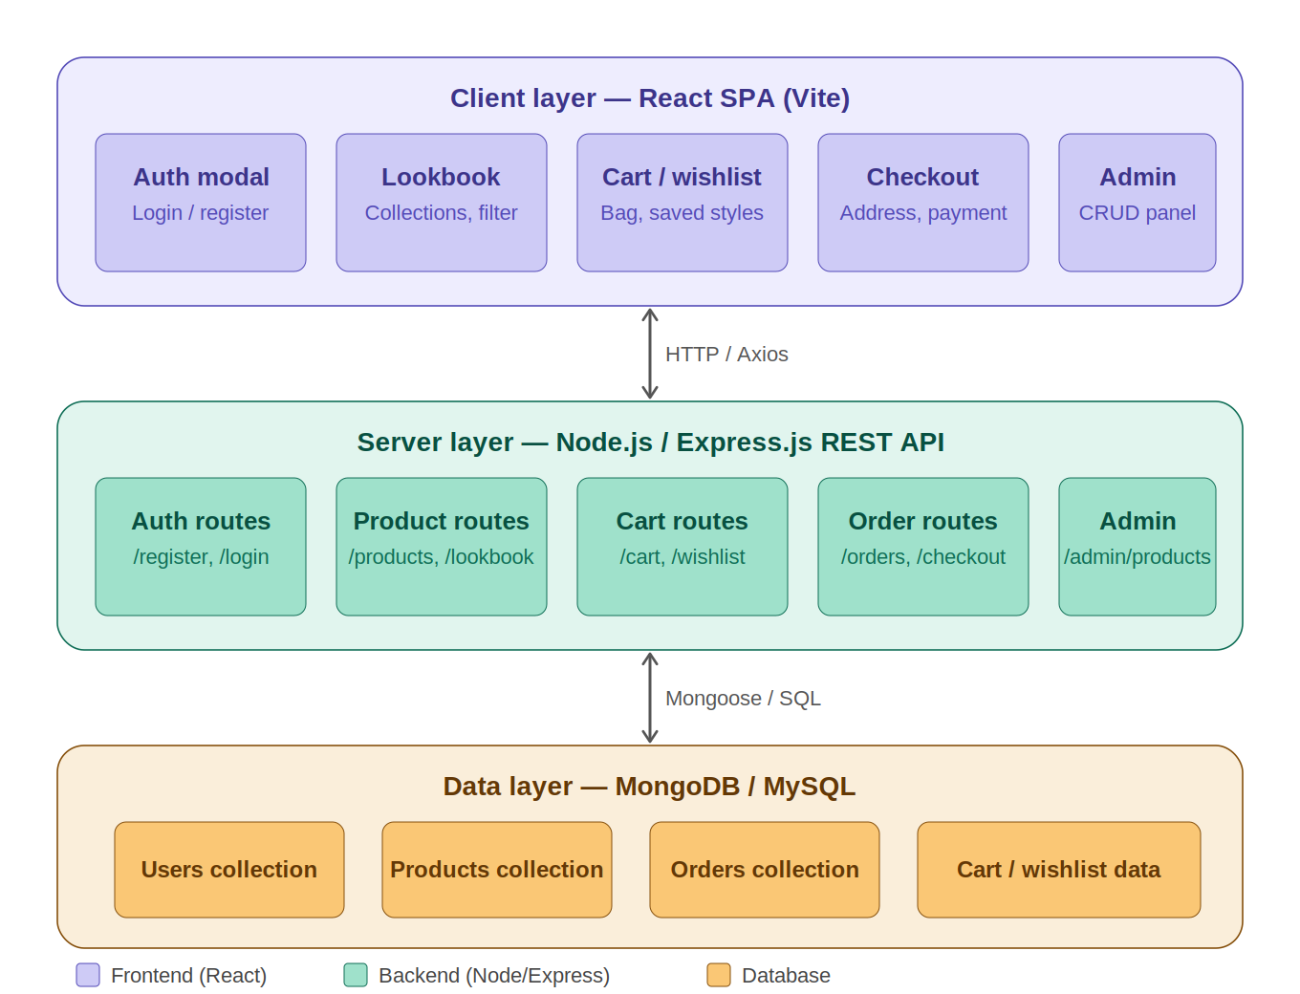
Figure 3.1: System Architecture Diagram

3.2 Component Hierarchy
Component | Responsibility
App.jsx | Root component — holds <Routes>, global auth context, and cart state
Navbar.jsx | Navigation bar — <Link> components, auth-aware (login/logout toggle)
ProtectedRoute.jsx | Guards private routes — redirects to /login if unauthenticated
LookbookPage.jsx | Displays outfit collections with filter controls (occasion, season)
ProductCard.jsx | Reusable outfit/product card — shows image, name, price, add-to-cart button
CartPage.jsx | Cart view — list of added items, quantity updates, total calculation
WishlistPage.jsx | Saved favourite outfits — add/remove from wishlist
CheckoutPage.jsx | Checkout flow — address form, order summary, payment UI
AdminPanel.jsx | Admin dashboard — CRUD for products and categories
AuthPage.jsx | Login & Signup forms with validation and session handling
ErrorBoundary.jsx | Catches runtime JS errors — shows fallback UI

3.3 Route Map
Path | Component | Access
/ | HomePage (Lookbook Landing) | Public
/login | AuthPage (Login) | Public
/signup | AuthPage (Signup) | Public
/lookbook | LookbookPage | Public
/lookbook/:id | ProductDetail (dynamic) | Public
/cart | CartPage | Protected (auth required)
/wishlist | WishlistPage | Protected (auth required)
/checkout | CheckoutPage | Protected (auth required)
/admin | AdminPanel | Protected (admin only)
* | NotFoundPage | Public — 404 fallback

3.4 UI Wireframes
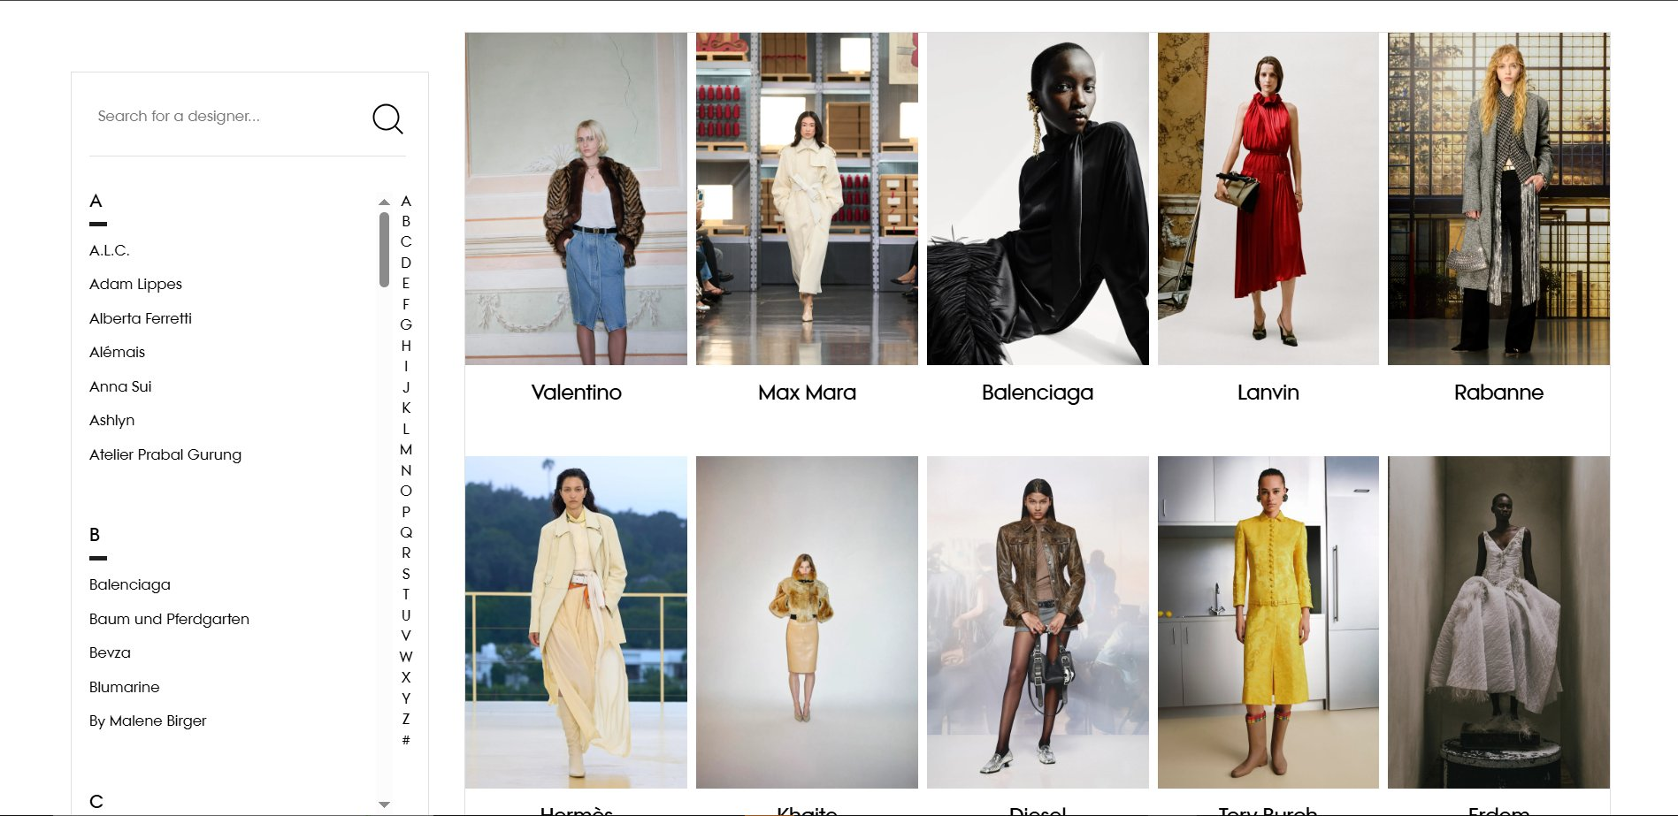
Figure 3.2: Designer Browse / Lookbook Landing Wireframe

Chapter 4: Implementation

4.1 Technology Stack
Category | Technology | Purpose
UI Library | React.js 18 | Component-based SPA development
Routing | React Router v6 | Client-side navigation and protected routes
Build Tool | Vite | Fast development server and bundling
Styling | Bootstrap / CSS | Responsive layout and component styling
State Management | useState / Context API | Global auth state, cart state management
Back End | Node.js + Express.js | REST API server and business logic
Database | MongoDB / MySQL | Persistent storage of users, products, orders
ORM / Query | Mongoose / SQL Queries | Database schema and query management
API / Data | REST APIs + Axios | HTTP requests between front end and back end
Storage | Local Storage | Persist cart and session data client-side
Payment | Payment Gateway UI | Checkout payment interface integration
Version Control | Git & GitHub | Source code management

4.2 Key Modules

4.2.1 User Authentication Module
User authentication was implemented with login and signup forms using React controlled components. Upon successful authentication, a session token is stored in Local Storage and a global Auth Context provides the authenticated state to protected routes. The ProtectedRoute component checks authentication status and redirects unauthenticated users to /login.

import React, { useState } from "react";
import { useApp } from "./AppContext";

export default function AuthModal() {
const { showAuthModal, setShowAuthModal, loginUser, registerUser } = useApp();
const [isRegister, setIsRegister] = useState(false);
const [email, setEmail] = useState("");
const [name, setName] = useState("");
const [password, setPassword] = useState("");

const handleSubmit = async (e) => {
e.preventDefault();
if (isRegister) {
const ok = await registerUser(name, email, password);
if (ok) { setShowAuthModal(false); resetForm(); }
} else {
const ok = await loginUser(email, password);
if (ok) { setShowAuthModal(false); resetForm(); }
}
};

// Demo login shortcut for project review
const handleDemoLogin = async (role) => {
if (role === "kartheek") {
const ok = await loginUser("kartheek@style.com", "123");
if (ok) setShowAuthModal(false);
} else {
const ok = await loginUser("apoorva@style.com", "123");
if (ok) setShowAuthModal(false);
}
};

if (!showAuthModal) return null;
return (
<div className="fixed inset-0 z-50 flex items-center justify-center bg-black/60">
<form onSubmit={handleSubmit} className="bg-white p-6 w-full max-w-md border-2">
{isRegister && (
<input type="text" value={name}
onChange={(e) => setName(e.target.value)} placeholder="Full Name" required />
)}
<input type="email" value={email}
onChange={(e) => setEmail(e.target.value)} placeholder="Email" required />
<input type="password" value={password}
onChange={(e) => setPassword(e.target.value)} placeholder="Password" required />
<button type="submit">{isRegister ? "REGISTER" : "LOGIN"}</button>
<button type="button" onClick={() => handleDemoLogin("kartheek")}>
Demo: Kartheek (Admin)
</button>
<button type="button" onClick={() => handleDemoLogin("apoorva")}>
Demo: Apoorva (Cart & Checkout)
</button>
</form>
</div>
);
}

4.2.2 Fashion Lookbook & Filtering Module
The LookbookPage component fetches outfit collections from the REST API and renders them as ProductCard components. Filter controls allow users to narrow results by occasion (casual, formal, party), season (summer, winter, festive), or category. Filtering is handled client-side using React state to avoid unnecessary API calls during browsing.

import React, { useState } from "react";
import { useApp } from "./AppContext";

export default function LookbookSection() {
const { lookbooks, products, addToCart, toggleWishlist, isProductInWishlist } = useApp();
const [selectedCollection, setSelectedCollection] = useState(null);

// Filter products belonging to a chosen lookbook collection
const getCollectionProducts = (col) => {
return products.filter((p) => col.productIds.includes(p.id));
};

// Add all in-stock pieces from a collection to cart
const handleAddAllToCart = (col) => {
const matched = getCollectionProducts(col);
for (const p of matched) {
if (p.inventory > 0) addToCart(p, "M", 1);
}
};

return (
<div className="max-w-7xl mx-auto px-4 py-8">
<div className="grid grid-cols-1 md:grid-cols-3 gap-10">
{lookbooks.map((col) => {
const matchedCount = getCollectionProducts(col).length;
return (
<div key={col.id} className="group relative bg-white border overflow-hidden flex flex-col">
<div className="aspect-[3/4] overflow-hidden relative">
<img src={col.coverUrl} alt={col.name}
className="w-full h-full object-cover group-hover:scale-105 transition-transform duration-700" />
<div className="absolute inset-0 bg-gradient-to-t from-black/95 via-black/50 to-transparent
flex flex-col justify-end p-6 text-white">
<span className="text-xs text-amber-400 uppercase">{col.season} Collection</span>
<h3 className="text-2xl font-bold">{col.name}</h3>
<p className="text-xs text-stone-300 mt-2 line-clamp-2">{col.description}</p>
<div className="mt-4 flex justify-between items-center border-t border-white/10 pt-3">
<span className="text-xs text-stone-400">{matchedCount} matching pieces</span>
<button onClick={() => setSelectedCollection(col)}
className="text-amber-400 text-xs font-bold uppercase">
Explore Outfit
</button>
</div>
</div>
</div>
</div>
);
})}
</div>

{/* Outfit detail modal with wishlist & cart actions */}
{selectedCollection && (
<div className="fixed inset-0 z-50 flex items-center justify-center bg-black/70">
<div className="bg-white w-full max-w-4xl flex flex-col md:flex-row max-h-[90vh]">
<div className="flex-1 overflow-y-auto p-6">
{getCollectionProducts(selectedCollection).map((p) => (
<div key={p.id} className="flex items-center justify-between border p-3 mb-3">
<img src={p.imageUrl} alt={p.name} className="w-12 h-16 object-cover" />
<div className="flex-1 px-3">
<span className="text-xs text-amber-500">{p.category}</span>
<h4 className="text-sm font-bold">{p.name}</h4>
<span className="font-mono text-sm">&#8377;{p.price.toLocaleString()}</span>
</div>
<div className="flex gap-2">
<button onClick={() => toggleWishlist(p)}>
{isProductInWishlist(p.id) ? "&#10084;" : "&#9825;"}
</button>
<button onClick={() => addToCart(p, "M", 1)}
disabled={p.inventory === 0}>
{p.inventory === 0 ? "Out" : "Add"}
</button>
</div>
</div>
))}
</div>
</div>
</div>
)}
</div>
);
}

4.2.3 Cart & Wishlist Module
The cart and wishlist features were built by Chinmaya Apoorva. The cart supports adding and removing fashion items, updating quantities, and computing the total price dynamically. Cart state is persisted to Local Storage so it survives page refreshes. The wishlist allows users to save favourite outfits and move them directly to the cart.

Technologies used: React.js, JavaScript, Local Storage / API Integration, Bootstrap / CSS.

import React from "react";
import { useApp } from "./AppContext";

export default function CartWishlist({ isOpen, onClose, onOpenCheckout, activePanel, setActivePanel }) {
const { cart, wishlist, removeFromCart, updateCartQuantity, toggleWishlist, addToCart } = useApp();

if (!isOpen) return null;

// Dynamic billing calculations
const subtotal = cart.reduce((total, item) => total + item.product.price * item.quantity, 0);
const shipping = subtotal > 3000 ? 0 : 150;
const tax = Math.round(subtotal * 0.08 * 100) / 100;
const grandTotal = subtotal + shipping + tax;

return (
<div className="fixed inset-0 z-50 flex justify-end bg-black/50">
<div className="bg-white w-full max-w-md h-full flex flex-col border-l-2">

{/* Tab toggle: Cart vs Wishlist */}
<div className="p-5 border-b flex justify-between items-center">
<div className="flex space-x-5">
<button onClick={() => setActivePanel("cart")}
className={activePanel === "cart" ? "font-bold border-b-2 border-black" : "text-stone-400"}>
Couture Bag ({cart.length})
</button>
<button onClick={() => setActivePanel("wishlist")}
className={activePanel === "wishlist" ? "font-bold border-b-2 border-black" : "text-stone-400"}>
Saved Styles ({wishlist.length})
</button>
</div>
<button onClick={onClose}>&#10005;</button>
</div>

{/* Cart items list */}
<div className="flex-1 overflow-y-auto p-5 space-y-4">
{activePanel === "cart" ? (
cart.map((item, idx) => (
<div key={idx} className="flex gap-4 border p-3">
<img src={item.product.imageUrl} alt={item.product.name}
className="w-16 h-20 object-cover" />
<div className="flex-1 flex flex-col justify-between">
<h4 className="text-xs font-bold">{item.product.name}</h4>
<span className="font-mono font-bold">
&#8377;{item.product.price.toLocaleString()}
</span>
<div className="flex justify-between items-center mt-2">
{/* Quantity controls */}
<div className="flex items-center gap-2">
<button onClick={() => updateCartQuantity(item.product.id, item.size, item.quantity - 1)}
disabled={item.quantity <= 1}>&#8722;</button>
<span>{item.quantity}</span>
<button onClick={() => updateCartQuantity(item.product.id, item.size, item.quantity + 1)}
disabled={item.quantity >= item.product.inventory}>&#43;</button>
</div>
<button onClick={() => removeFromCart(item.product.id, item.size)}>&#128465;</button>
</div>
</div>
</div>
))
) : (
/* Wishlist panel: move to cart or remove */
wishlist.map((p) => (
<div key={p.id} className="flex items-center justify-between border p-3">
<img src={p.imageUrl} alt={p.name} className="w-12 h-16 object-cover" />
<h4 className="flex-1 px-3 text-xs font-bold">{p.name}</h4>
<button onClick={() => { addToCart(p, "M", 1); toggleWishlist(p); }}>
Move to Bag
</button>
<button onClick={() => toggleWishlist(p)}>Remove</button>
</div>
))
)}
</div>

{/* Billing footer (cart panel only) */}
{activePanel === "cart" && cart.length > 0 && (
<div className="p-5 border-t space-y-2 font-mono text-sm">
<div className="flex justify-between">
<span>Subtotal</span><span>&#8377;{subtotal.toLocaleString()}</span>
</div>
<div className="flex justify-between">
<span>Shipping</span><span>{shipping === 0 ? "FREE" : `&#8377;${shipping}`}</span>
</div>
<div className="flex justify-between">
<span>Tax (8%)</span><span>&#8377;{tax.toLocaleString()}</span>
</div>
<div className="flex justify-between font-black text-base border-t pt-2">
<span>Grand Total</span><span>&#8377;{grandTotal.toLocaleString()}</span>
</div>
<button onClick={() => { onClose(); onOpenCheckout(); }}
className="w-full py-4 bg-black text-white font-bold uppercase tracking-widest">
INJECT CHECKOUT DRAFT &#8594;
</button>
</div>
)}
</div>
</div>
);
}

4.2.4 Checkout Module
The checkout flow was developed by Chinmaya Apoorva. It includes an address form with validation, an order summary showing selected items and totals, and a payment UI integrated with a payment gateway interface. On successful payment confirmation, an order confirmation page is displayed.

Technologies used: React.js, HTML/CSS, JavaScript, Payment Gateway UI Integration.

import React, { useState } from "react";
import { useApp } from "./AppContext";

export default function CheckoutModal({ isOpen, onClose }) {
const { cart, placeOrder, currentUser, isLoading } = useApp();

// Address form state
const [fullName, setFullName] = useState(currentUser?.name || "");
const [street, setStreet] = useState("102 Fashion Boulevard, High Street");
const [city, setCity] = useState("Vogue District");
const [zipCode, setZipCode] = useState("500015");
const [country, setCountry] = useState("India");

// Payment state
const [payMethod, setPayMethod] = useState("card");
const [cardNumber, setCardNumber] = useState("4111 2222 3333 4444");
const [cardExpiry, setCardExpiry] = useState("12/28");
const [cardCvv, setCardCvv] = useState("321");

// Success receipt state
const [placedOrder, setPlacedOrder] = useState(null);

if (!isOpen) return null;

const subtotal = cart.reduce((t, i) => t + i.product.price * i.quantity, 0);
const shipping = subtotal > 3000 ? 0 : 150;
const tax = Math.round(subtotal * 0.08 * 100) / 100;
const grandTotal = subtotal + shipping + tax;

const handleCheckoutSubmit = async (e) => {
e.preventDefault();
const address = { fullName, street, city, zipCode, country };
const payment = {
method: payMethod,
cardLast4: payMethod === "card" ? cardNumber.split(" ").pop() : undefined,
};
const result = await placeOrder(address, payment);
if (result) setPlacedOrder(result);
};

return (
<div className="fixed inset-0 z-50 flex items-center justify-center bg-black/60">
<div className="bg-white w-full max-w-4xl flex flex-col md:flex-row max-h-[92vh]">

{placedOrder ? (
/* Order success confirmation screen */
<div className="flex-1 p-8 text-center flex flex-col items-center justify-center space-y-6">
<h2 className="text-3xl font-black uppercase">Thank you, {placedOrder.buyerName}!</h2>
<p className="text-xs text-stone-600">Order ID: {placedOrder.id}</p>
<div className="w-full bg-white border p-5 text-left text-xs font-mono space-y-3">
<span className="text-amber-500 font-bold uppercase">Order Invoice Summary</span>
{placedOrder.items.map((item, id) => (
<div key={id} className="flex justify-between py-2 border-b">
<span className="font-bold uppercase">{item.product.name}
<span className="text-stone-400 ml-2">Size {item.size} x {item.quantity}</span>
</span>
<span>&#8377;{(item.product.price * item.quantity).toLocaleString()}</span>
</div>
))}
<div className="flex justify-between font-black border-t pt-2">
<span>Grand Total</span>
<span>&#8377;{placedOrder.total.toLocaleString()}</span>
</div>
</div>
<button onClick={() => { setPlacedOrder(null); onClose(); }}
className="px-8 py-3 bg-black text-white font-bold uppercase">
Return to Catalog
</button>
</div>
) : (
/* Checkout form + order summary side panel */
<>
<form onSubmit={handleCheckoutSubmit} className="flex-1 p-8 flex flex-col overflow-y-auto">
<h2 className="text-2xl font-black uppercase mb-6">Secure Checkout</h2>

{/* Address fields */}
<input type="text" value={fullName}
onChange={(e) => setFullName(e.target.value)} placeholder="Full Name" required />
<input type="text" value={street}
onChange={(e) => setStreet(e.target.value)} placeholder="Street Address" required />
<div className="grid grid-cols-2 gap-3">
<input type="text" value={city}
onChange={(e) => setCity(e.target.value)} placeholder="City" required />
<input type="text" value={zipCode}
onChange={(e) => setZipCode(e.target.value)} placeholder="ZIP Code" required />
</div>

{/* Payment method toggle */}
<div className="grid grid-cols-3 gap-2 mt-4">
{["card", "upi", "paypal"].map((m) => (
<button key={m} type="button" onClick={() => setPayMethod(m)}
className={payMethod === m ? "bg-black text-white" : "border"}>
{m.toUpperCase()}
</button>
))}
</div>

{payMethod === "card" && (
<div className="mt-3 space-y-2 bg-stone-50 p-4 border">
<input type="text" value={cardNumber}
onChange={(e) => setCardNumber(e.target.value)} placeholder="Card Number" required />
<div className="grid grid-cols-2 gap-3">
<input type="text" value={cardExpiry}
onChange={(e) => setCardExpiry(e.target.value)} placeholder="MM/YY" required />
<input type="password" value={cardCvv}
onChange={(e) => setCardCvv(e.target.value)} placeholder="CVV" required />
</div>
</div>
)}

<button type="submit" disabled={isLoading || cart.length === 0}
className="mt-6 w-full py-4 bg-black text-white font-bold uppercase">
{isLoading ? "AUTHORIZING..." : `PLACE ORDER (&#8377;${grandTotal.toLocaleString()})`}
</button>
</form>

{/* Right panel: order summary */}
<div className="md:w-5/12 bg-stone-50 border-l p-8 flex flex-col overflow-y-auto">
<span className="font-mono text-xs font-bold uppercase mb-4">Review Summary</span>
{cart.map((item, id) => (
<div key={id} className="flex items-center gap-3 mb-3 pb-3 border-b">
<img src={item.product.imageUrl} alt={item.product.name}
className="w-10 h-14 object-cover" />
<div>
<h4 className="text-xs font-bold uppercase">{item.product.name}</h4>
<span className="text-xs text-stone-500">
Size: {item.size} x {item.quantity}
</span>
<span className="font-mono font-bold block">
&#8377;{item.product.price.toLocaleString()}
</span>
</div>
</div>
))}
<div className="mt-auto pt-4 border-t space-y-1 font-mono text-sm">
<div className="flex justify-between"><span>Subtotal</span>
<span>&#8377;{subtotal.toLocaleString()}</span></div>
<div className="flex justify-between"><span>Shipping</span>
<span>{shipping === 0 ? "FREE" : `&#8377;${shipping}`}</span></div>
<div className="flex justify-between"><span>Tax (8%)</span>
<span>&#8377;{tax.toLocaleString()}</span></div>
<div className="flex justify-between font-black text-base border-t pt-2">
<span>Grand Total</span><span>&#8377;{grandTotal.toLocaleString()}</span>
</div>
</div>
</div>
</>
)}
</div>
</div>
);
}

4.2.5 Admin Panel Module
The admin panel was built by Kartheek Reddy. It provides an admin dashboard to manage products and fashion collections, supporting add, edit, and delete operations on products. Admins can manage categories, outfit collections, and product details through a protected admin-only route.

Technologies used: Node.js, Express.js, MongoDB / MySQL, React.js.

4.2.6 Database Management
Database design and management was handled by Kartheek Reddy. The database stores user details, products, cart data, and order information. Mongoose schemas (for MongoDB) or SQL table definitions (for MySQL) were created to enforce data integrity. Back-end APIs connect to the database to serve product, cart, and order data to the front end.

Technologies used: MongoDB / MySQL, Mongoose / SQL Queries, REST APIs.

4.3 Challenges and Solutions
Challenge | Solution Adopted
Managing cart state across components without prop drilling | Used React Context API (CartContext) with useReducer to provide cart state globally
Keeping wishlist and cart in sync after page refresh | Persisted cart and wishlist state to Local Storage; loaded on app initialization
Handling protected routes for both user and admin roles | Created a role-aware ProtectedRoute component that checks both auth status and user role
Connecting React front end to Node.js back end across environments | Used Axios with a base URL config; .env files for environment-specific API endpoints
Dynamic outfit filtering without additional API calls | Applied client-side filter state on the fetched dataset using Array.filter() in React state

Chapter 5: Testing

5.1 Test Cases
TC ID | Module | Test Description | Expected Result | Status
TC-01 | Authentication | Register with valid credentials | Account created; redirected to login | Pass ✅
TC-02 | Authentication | Login with correct credentials | Session created; redirected to home | Pass ✅
TC-03 | Routing | Access /cart without login | Redirected to /login | Pass ✅
TC-04 | Lookbook | Apply occasion filter = Formal | Only formal outfits displayed | Pass ✅
TC-05 | Cart | Add item to cart; check quantity update | Item appears in cart; quantity increments | Pass ✅
TC-06 | Cart | Remove item from cart | Item removed; total recalculated | Pass ✅
TC-07 | Wishlist | Add outfit to wishlist | Outfit saved to wishlist page | Pass ✅
TC-08 | Checkout | Submit checkout with empty address field | Validation error shown below field | Pass ✅
TC-09 | Checkout | Complete checkout flow | Order summary confirmed; success screen shown | Pass ✅
TC-10 | Admin | Add new product from admin panel | Product appears in lookbook collection | Pass ✅
TC-11 | Admin | Delete product from admin panel | Product removed from collection listing | Pass ✅
TC-12 | Responsive | View app on mobile (375px) | Layout adjusts; no overflow or broken elements | Pass ✅

Chapter 6: Results and Discussion

6.1 Screenshots
[ Insert screenshots of the working application. Add figure number and caption for each. Recommended: Home/Lookbook page, filtered lookbook view, cart page, wishlist, checkout, and admin panel. ]

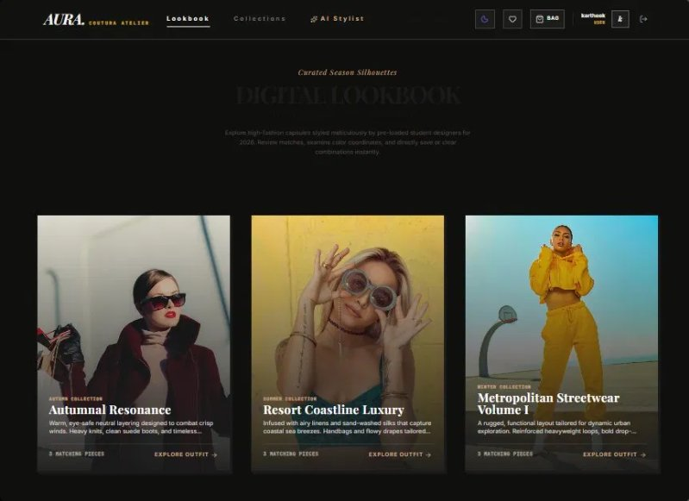
Figure 6.1: Home Page — Lookbook Landing View (Desktop)

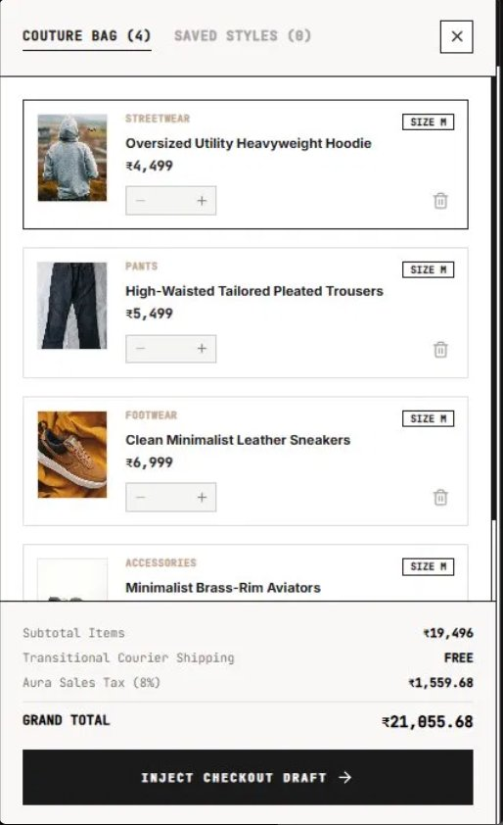
Figure 6.2: Cart Page with Item Management

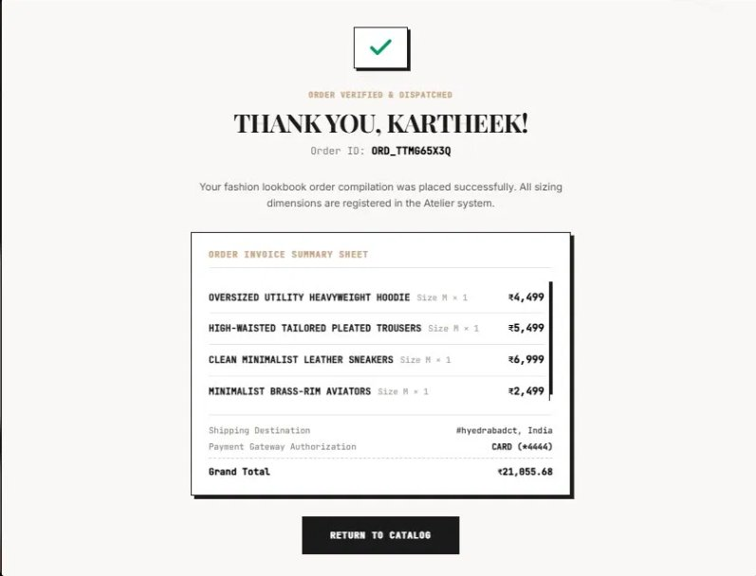
Figure 6.3: Checkout Page — Address Form and Order Summary

6.2 Discussion
The Fashion Lookbook & Style Guide application successfully achieved its primary objectives. The React.js SPA delivered a seamless browsing experience with instant client-side navigation between the lookbook, cart, wishlist, and checkout pages. The component-based architecture ensured code reusability — the ProductCard component, for example, was used across the lookbook, wishlist, and admin views without duplication. Protected routes effectively restricted access to authenticated users, and the admin panel gave full product management capability.

The cart and wishlist modules performed reliably across different user scenarios, with Local Storage persistence ensuring cart data was not lost on page refresh. The checkout flow integrated smoothly with the payment gateway UI, though the full payment processing logic is outside the current scope. One area for improvement is the client-side filtering mechanism — as the product dataset grows, migrating filtering to server-side pagination would significantly improve performance.

The database design using MongoDB/MySQL and REST APIs provided a flexible and consistent data layer. The dual-database approach (supporting both MongoDB via Mongoose and MySQL via SQL queries) allowed the team to evaluate both solutions. The primary tradeoff identified was between MongoDB's schema flexibility (useful for dynamic fashion attributes) and MySQL's relational integrity (better for structured order and user data).

Chapter 7: Conclusion and Future Work

7.1 Conclusion
This project successfully delivered a full-stack Fashion Lookbook & Style Guide web application using React.js, Node.js, Express.js, and MongoDB/MySQL. All major objectives were met: user authentication with session management was implemented, the fashion lookbook with filtering was built and integrated, the cart and wishlist modules are functional with persistent state, and the checkout flow with payment UI was completed. The admin panel enables full product and collection management. The application is responsive across desktop, tablet, and mobile screen sizes, delivering a consistent and accessible user experience.

7.2 Lessons Learned
- Dividing module responsibilities clearly from the start allowed parallel development and reduced merge conflicts between team members.
- React Context API with useReducer is a scalable pattern for managing cart and auth state without introducing Redux overhead for a project of this size.
- Persisting state to Local Storage must be paired with proper data validation on load to avoid stale or corrupt data affecting the UI.
- REST API design benefits from consistent naming conventions (GET /products, POST /cart/add) to reduce confusion between front-end and back-end developers.
- Testing protected routes and auth flows early in development prevents cascading issues in later modules that depend on session state.

7.3 Future Enhancements
- Integrate a full payment gateway (e.g., Razorpay or Stripe) with real transaction processing and order tracking.
- Implement a personalized outfit recommendation engine using user browsing history and preference data.
- Add server-side rendering (SSR) using Next.js for improved SEO and faster initial page load for fashion content.
- Introduce social features — users can follow fashion influencers, share lookbooks, and like outfits.
- Implement internationalisation (i18n) to support multiple languages and regional fashion trends.
- Add real-time inventory management in the admin panel with stock alerts and analytics dashboard.

Appendix

A. GitHub Repository
Project Repository URL:
https://github.com/Kartheekreddy1507P/FEDF-Fashion-Lookbook-Style-Guide

Branch: main | Commit history includes descriptive commit messages per module.

B. Installation
- Clone: git clone https://github.com/Kartheekreddy1507P/FEDF-Fashion-Lookbook-Style-Guide.git
- Navigate: cd FEDF-Fashion-Lookbook-Style-Guide
- Install front-end dependencies: cd client && npm install
- Install back-end dependencies: cd server && npm install
- Configure environment: create .env with DB URI, API keys, and JWT secret
- Start back end: npm run server
- Start front end: npm run dev
- Open in browser: http://localhost:5173

C. Individual Contribution
Student Name | Roll Number | Modules / Contributions
Podduturi Kartheek Reddy | 2520090015 | User Authentication, Fashion Lookbook, Admin Panel, Database Management
Muppana Chinmaya Apoorva | 2520030078 | Cart & Wishlist, Checkout Page, Payment UI, Responsive Design

